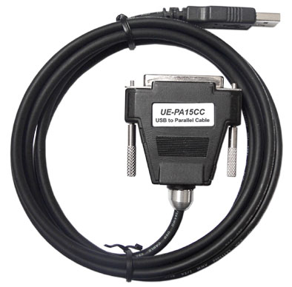
USB to Parallel Cable User’s Manual V2.4 _

Congratulations on your purchase of the USB to Parallel Cable
adapter. This unique cable adapter allows you to attach your
computer to most parallel printer device thru the USB port and
get faster printing results.

Package Checklist
The USB to Parallel Cable product package includes the following items:
- The USB to Parallel Cable
- Driver Installation Diskette
- This User's Manual

Overview
The USB to Parallel cable allows your PC to print to most parallel printer device connected through the USB port. Just plug the USB connector of the cable into the USB port of your PC and the other end into the Centronics connector of the parallel printer. USB (Universal Serial Bus) interface provides up to 12Mbps data throughput, so printing is much faster compared when connected to standard parallel port (150kbs). The USB to Parallel cable also provides true plug-n-play and hot-plug capability - simply plug in the cable under the Windows operating system and the cable will be instantly detected.

Features
The USB to Parallel cable provides the following features:
- Single chip (ASIC) USB to Parallel communication
- Windows 98/Me and Windows 2000/XP Support
- Mac OS8/OS9 Support
- Universal Serial Bus Specification Rev. 1.1 compliant
- USB full speed communication and bus powered
- USB Printer Class Specification 1.0 compliant
- IEEE-1284 1994 (bi-directional parallel interface) specification compliant

System Requirements
Before you use the USB to Parallel cable, make sure your computer is an IBM PC-compatible with the following minimum system requirements:
- Intel-compatible 486DX-66 MHz CPU or higher
- One standard 4-pin USB port (with the symbol )
- Either the following operating systems:
- Windows 98/Me or Windows 2000/XP
Driver Installation

Notice: : The driver of USB-Parallel Bridge only supported for Win98/ Win98SE/ Win ME. About the driver for Win2000/XP, Microsoft has followed IEEE 1284 Specification to support a standard driver bundled in Win2000. When you plug in the cable, Win2000/XP will automatically detect the USB-Parallel Bridge cable & install the bundled driver.
Follow the steps below on installing the USB to Parallel cable software:

- Power on your computer and make sure that the USB port is enabled and working properly.

- Plug in the USB to Parallel cable into the USB port and Windows will detect the IEEE-1284 device and run the Add New Hardware Wizard to assist you in setting up the new device. Click Next to continue.

- Insert the USB to Parallel cable driver diskette into the floppy drive and click Next to continue. For Windows 98, click Search for the best driver for your device and click to search driver from the floppy disk drive.

- Windows will detect the driver (U2PAR.INF) and shows the IEEE-1284 Controller device. Click Next to continue installation.
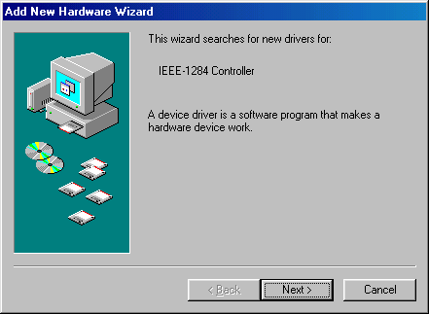
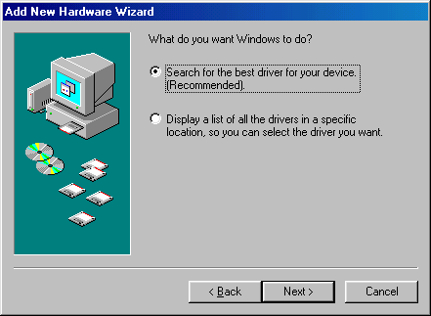
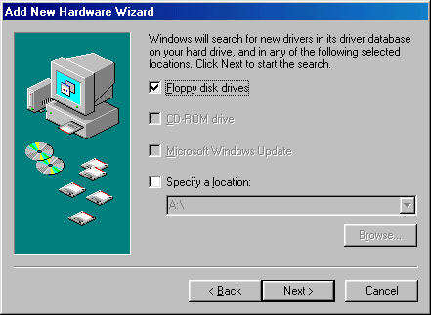

- Click Next to continue and let Windows copy the needed files to your hard disk.
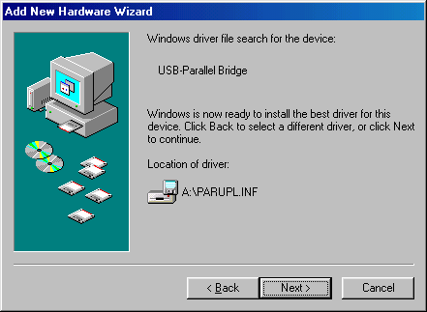
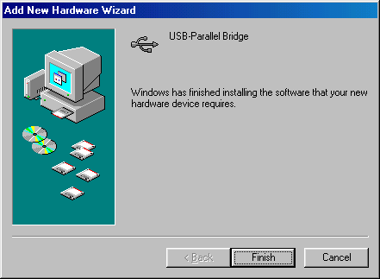
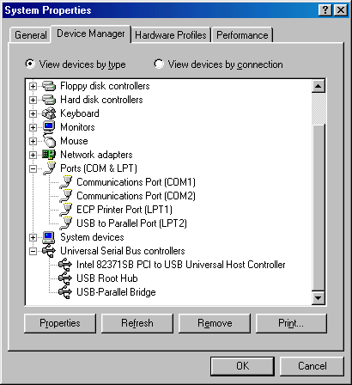
- When Windows finished installing the software required for the new USB-Parallel Bridge device, click Finish.

Setting Up the Printer Device

Follow the steps below on how to connect your printer to the USB port of your PC:

- Turn off your printer. Plug the Centronics connector of the “USB to Parallel cable” into your printer through a parallel cable. Turn on the printer afterwards.
- Turn on your computer and plug in the USB connector of the USB to Parallel cable into the USB port.
- If you have already installed a printer device before, click Start, Settings, Printers. Right-click the default-installed printer and click on Properties. The Properties dialog box of the installed printer will appear on your screen.
- Click the Details folder tab and change the printer port to LPT2: (USB to Parallel Port).
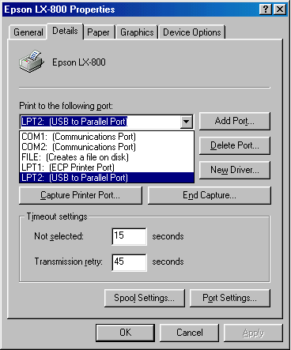

- If you do not have a printer installed yet, click on Start, Settings, Printers, Add Printer. The Add Printer Wizard will start and assist you in installing a new printer device. Select the printer manufacturer and model name from the list provided by the wizard or use the printer driver diskette supplied with your printer.

- When prompted which port the printer will use, click on LPT2: USB to Parallel Port.

- Follow the succeeding instructions to complete the installation and also run Print Test Page to see if it can print without problems.

Uninstalling the Driver Program
If in any case you want to remove the USB to Parallel cable driver program, you can uninstall it by following the steps below:
1. Unplug the USB to Parallel cable from your PC.
2. Run the UNINST.EXE program from the USB to Parallel cable driver diskette and reboot the PC.

More Information
If you need more information please visit website:
http://www.prolific.com.tw

Disclaimer
Information in this document is subject to change without notice. The manufacturer does not make any representations or warranties (implied or otherwise) regarding the accuracy and completeness of this document and shall in no event be liable for any loss of profit or any other commercial damage, including but not limited to special, incidental, consequential, or other damages.

No part of this document may be reproduced or transmitted in any form by any means, electronic or mechanical, including photocopying, recording or information recording and retrieval systems without the express written permission of the manufacturer.

All brand names and product names used in this document are trademarks, or registered trademarks of their respective holders.

FCC Statement
This device generates and uses radio frequency and may cause interference to radio and television reception if not installed and used properly. This has been tested and found to comply with the limits of a Class B computing device in accordance with the specifications in Part 15 of FCC Rules. These specifications are designed to provide reasonable protection against such interference in a residential installation. However, there is no guarantee that interference will not occur in a particular installation. If this device does cause harmful interference to radio or television reception, which can be determined by plugging the device in and out, the user can to try to correct the interference by one or more of the following measures:

- Reorient or relocate the receiving antenna.
- Increase the separation between the device and receiver.
- Connect the computer into an outlet on a circuit different from that to which the receiver is connected.
- Consult the dealer or an experienced radio/TV technician for help.
Copyright ©2002 All rights reserved.

