ARCHEON YC-100D File-Transfer Cable

User Guide

Overview
ARCHEON YC-100D File-Transfer Cable is a windows-based application for transferring files. You can connect your PC to another PC with ARCHEON YC-100D File-Transfer Cable, and easily transfer and manipulate files and directories on either machine. It’s fast solution to peer-to-peer file transfer between two computers via the USB port, and gives you the greater speed than traditional file transfer products via serial or parallel port.

System Requirement
OS –Win95 OSR2, Windows 98/ME/2000/XP ,WinNT3.5 or up
one available USB slot

Installation
Before using ARCHEON YC-100D File-Transfer cable, you must install the driver for the cable and the application software in both computers that you would like to connect.

Install the Application:
1. Insert the installation disk in your floppy disk driver.
2. Find the execution file [Setup.exe] on the disk and execute it.
3. Follow the on-screen instructions to complete the installation of the application.
4. After installation the application, the operation system will create a shortcut icon on desktop and one folder on program manager.
5. Do the same procedures for the other computer.

Cable Connection and Install the Driver
- Find an USB port on one computer and connect one connector of the ARCHEON YD-100D File-Transfer cable to that port.
- When you connect the cable to a computer in the very first time, the system will detect the cable as a new device, and ask for the driver for it. Insert the installation disk that comes with the cable and follow the on-screen instructions to complete the installation of the driver
- Find an USB port on the other computer and connect the other connector of the ARCHEON YC-100D File-Transfer cable to that port. Follow step 1 and 2 to install the driver.

If you have installed the application and device driver, and also connect both computers, you can execute the application in both computers to establish the link.

User Interface
The user interface of application is made up of several functional areas:
1. Menu bar and Tool bar, providing quick file transfer and file manipulating functions.
2. Local and Remote desktop, showing you the status of local PC and the PC you are connected to.
3. Popup menu displays some functions that are specific to the selected files when mouse right click.
4. Status bar displays the description of the acting function.

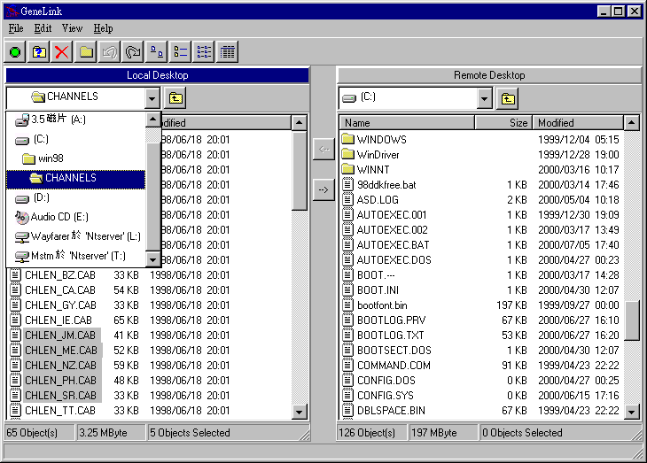
Status bar
Listview
Combox
Menu & tool bar

Connection
indicator
Local desktop
Remote desktop

The Local and Remote Desktop
The Local/Remote Desktop represents the file structure of each computer that the application is running. It provides an interface that is similar to Windows Explorer File Manager. The combox of the Local/Remote Desktop shows the drive letters and folder names, while the listview shows the files contained in the selected folder. The Remote Desktop will appear only if remote computer has been connected and the application software is running, too.

The Connection Indicator
The connection indicator shows you the status of current connection. There are three different color indicators at the top left corner of the application window.
- Red Indicator, it means the connection between the local and remote computer is not established. The ARCHEON YC-100D File-Transfer cable is not connected properly to the local computer, therefore there is no way to get the status of the remote desktop.
- Yellow Indicator, it means the cable is connected to the local computer, but the cable is not connected properly to the remote computer or the application is not running.
- Green Indicator, it means the connection between the local and remote computer is established. The cable is connected to both computers and the application is running well on the local and remote computer.

Working with Folders and Files
After connecting both computers, you can use the file and directory manipulating functions to browse file systems on local and remote desktop. Just go to menu bar and tool bar, you can use those menu commands or click on command icons to perform directory and file operations. You can also access these functions from the popup menu that appears when you click the right mouse button in the desktop’s listview that showing directories and files.
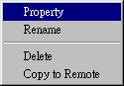

Selecting Directories and Files
To select a directory or file in the current directory, click on the directory or file name in the desktop’s listview. To select multiple files or directories:
1. If the files or directories are contiguous in the listview, click on the first file to be selected, and then press Shift key and click on the last file to be selected.
2. If the files or directories are not contiguous, click on the first file to be selected, and then press Ctrl key and click on any other files you want to select.
3. To unselect all directories and files, click in a blank area of the listview.

Changing the drive and directory
1. The currently displayed directory shown in combox of the local and remote desktop also show you the name of your local/remote disk drive.
2. To change the disk drive selection, you can click on the combox and double-click on the appropriate drive letter. Your disk drives are shown by a drive letter (for example, a:, c:, d:) and a disk icon.
3. To change to another directory, you can directly double-click on a directory name shown on the combox or listview to change to that directory.
4. You can switch back to last directory by clicking up folder button on the desktop.

Changing the appearance of items in a folder listview
Click on Large Icons, Small Icons and List or Details to change the item appearance in an active folder listview.

Displaying Directory and File Information
Click the button or popup menu’s “Property” item, the software will show the information of the selected directory or file in the current directory.

Create a directory
Click on the button, you can create a new, empty directory, which is using the default name “NewFolderXX”. The directory is created as a subdirectory of the currently displayed directory in the active desktop. Not all active folders allow you to create directory.

Renaming Files
Select one file or directory, and click the popup menu’s “Rename” item, you can rename selected file or directory, and are prompted for the new name. Not all active folder allow you to rename file and directory.

Deleting Files
Select the file that you would like to delete and then click on the Delete button . You will be prompted for delete confirmation. Click “Yes” to delete the item or “No” to cancel. Not all systems will allow you to delete files.

Sorting Directories and Files
You can sort the order of directories and files on either the local or remote desktop’s listview box by using the column headings (Name, Size, Modified date) above each list.

Transferring Folders and Files
Copying files and directories between two computers that are connected by the High-Edge HE100 File-Transfer cable is easy. Just use the “drag & drop” feature or the copy operations to transfer selected files or directories from the Local desktop to the Remote desktop or vice versa.
- Select destination directory that you want to transfer files in the destination desktop.
- Select the files or directories in the source desktop.
- Transfer selected files by using the left and right arrow buttons. Or just “drag” the files or directories from source desktop, then “drop” them to destination desktop.
- A Transfer Status dialog box will appear during file transfer and the transfer status will be displayed. The dialog box shows a “progress done bar” if the file size is sent from the source desktop during file transferring operation. You can click on the “Cancel” button on the dialog box in any time to cancel the transfer operation.

